

DUBBO DISTRICT JUNIOR CRICKET ASSOCIATION

GAME-DAY RULESHEETS

UNDER 9’S MASTER BLASTER


https://www.playcricket.com.au/cricket-blast/master-blasters

UNDER 10 CRICKET RULESHEET
Coach | Accredited Community (Level 1) Coach
Game Type | T20
Ball | - Incredi-Ball.
Time | 120 mins
Equipment | - Helmet’s may be worn at whilst batting & wicket-keeping.  - Protector  - Additional safety equipment can be worn based on match conditions and/or personal preference.  - Each team is to supply a set of portable “springback” stumps (with base and bails)  - Bat size: Size 4 (<1.8lb or < 800gm) is recommended  - Incredi-Ball (as per specifications above).  - Measuring tape or string to measure pitch length and boundary.  - Boundary markers  - Chalk, tape or paint to mark crease.
Boundary | 40m (max) - measured from the batters end stumps
Pitch length | 16m length measured stump to stump
Overs | 20 overs per team
Team Size | - 7 players per team  - 5 players per team is the minimum required to play the game.  - 9 players is the maximum to be allocated to a team (maximum 7 players on field at any given time).
Innings | 1 innings of 20 overs per team
Batting | - All balls (regardless of whether wides/no balls) will be included in the batter’s ball count.  - Batter to swap end following a dismissal. If there is a run out the not out batter is required to face the next delivery.  - As there is allowances for varying team size, the following retirement rules apply:  - 5 player team – batters retire at 24 balls  - 6 player team – batters retire at 20 balls  - 7 player team – batters retire at 17 balls  - 8 player team – batters retire at 15 balls  - 9 player team – batters retire at 13 balls  - If there is an extra ball bowled, the batter facing at the time will face the extra ball (i.e. 17 x 7 = 119)
Bowling | - 6 balls per over (maximum)  - All players are to bowl (each Wicket-Keeper is to bowl one over each)  - Maximum overs bowled by a player are 4 overs  * Please see Recommended Bowling Breakdown for player options  - Bowlers are to bowl from the one end for the entire game
Fielding | - Rotation of fielders is required to ensure all players experience all positions  - No fielders within 15 metres of batter or each other (except Wicket-Keeper) to encourage singles and safety  - Each team is required to use a minimum of two (2) wicket keepers (10 overs each). Teams are encouraged to rotate so everyone can wicket-keep each game.  - If more than 7 players are present at a match, they should rotate onto the field each over.
Dismissals | - Unlimited dismissals (each player will face the nominated number of balls each)  - 4 runs per wicket taken will be added to the bowling team’s total at the end of the innings.  - The following dismissals apply in this format:  Bowled, Caught, Caught & Bowled, Run Out, Stumped, Hit Wicket.

Coaches also need to abide with the player participation requirements of junior cricket

UNDER 10’S CRICKET RULESHEET (Cont’d)
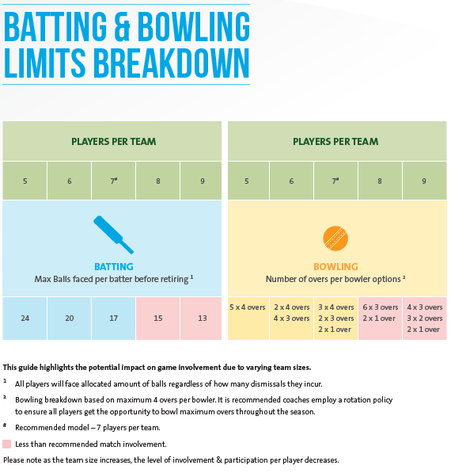

UNDER 10’S CRICKET RULESHEET (Cont’d)
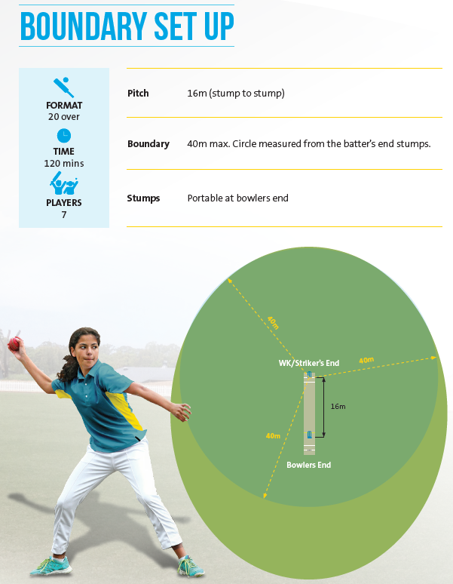

UNDER 10’S CRICKET RULESHEET (Cont’d)
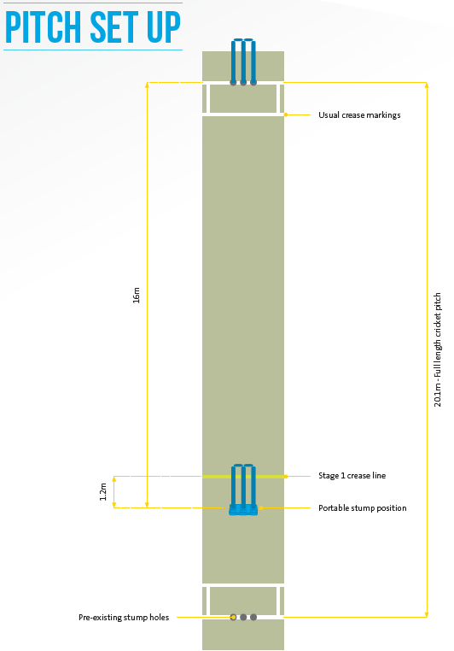

UNDER 12B CRICKET RULESHEET
Coach | Accredited Community (Level 1) Coach
Game Type | T20
Ball | - Approved composite ball.
Time | 120 mins
Equipment | - Helmets must be worn at all times whilst batting & wicket-keeping.  - Pads, Gloves, Protector  - Additional safety equipment can be worn based on match conditions and/or personal preference.  - 2 sets of portable stumps recommended (with base and bails) – minimum 1 set of portable stumps required.  - Bat size: Outdoor bat measured to suit player size and strength  - Modified ball (as per specifications above).  - Measuring tape or string to measure pitch length and boundary.  - Boundary markers  - Chalk, tape or paint to mark crease.
Boundary | 40m (max) - measured from the batters end stumps
Pitch length | 16m length measured stump to stump
Overs | 20 overs per team
Team Size | - 7 players per team  - 5 players per team is the minimum required to play the game.  - 9 players is the maximum to be allocated to a team (maximum 7 players on field at any given time).  - A team must have a minimum of five (5) players of their own club, 15 minutes after the scheduled commencement time of play to constitute sufficient players to play a match otherwise a forfeit will be declared. If players are to be loaned to opposing teams they can only field in a twelfth man capacity for the opposing team.
Innings | 1 innings of 20 overs per team

UNDER 12B’S CRICKET RULESHEET (Cont’d)
Batting | - All balls (regardless of whether wides/no balls) will be included in the batter’s ball count.  - Batter to swap end following a dismissal. If there is a run out the not out batter is required to face the next delivery.  - As there is allowances for varying team size, the following retirement rules apply:  - 5 player team – batters retire at 24 balls  - 6 player team – batters retire at 20 balls  - 7 player team – batters retire at 17 balls  - 8 player team – batters retire at 15 balls  - 9 player team – batters retire at 13 balls  - If there is an extra ball bowled, the batter facing at the time will face the extra ball (i.e. 17 x 7 = 119)
Bowling | - 6 balls per over (maximum)  - All players are to bowl (each Wicket-Keeper is to bowl one over each)  - Maximum overs bowled by a player are 4 overs  * Please see Recommended Bowling Breakdown for player options  - Bowlers are to bowl from the one end for the entire game  - Number of bounces before the ball reaches the batting crease is unlimited, as long as the ball is moving when it reaches the batsman. If a ball becomes stationary before the popping crease it is to be called no ball and immediately dead ball. The batsman may not play at the ball if stationary.
Fielding | - Rotation of fielders is required to ensure all players experience all positions  - No fielders within 15 metres of batter or each other (except Wicket-Keeper) to encourage singles and safety  - Each team is required to use two (2) wicket keepers (10 overs each)  - If more than 7 players are present at a match, they should rotate onto the field each over.
Dismissals | - Unlimited dismissals (each player will face the nominated number of balls each)  - 4 runs per wicket taken will be added to the bowling team’s total at the end of the innings.  - The following dismissals apply in this format:  Bowled, Caught, Caught & Bowled, Run Out, Stumped, Hit Wicket.

Coaches also need to abide with the player participation requirements of junior cricket

UNDER 12B’S CRICKET RULESHEET (Cont’d)

UNDER 12B’S CRICKET RULESHEET (Cont’d)

UNDER 12B’S CRICKET RULESHEET (Cont’d)

UNDER 12A CRICKET RULESHEET
Coach | - Accredited Community (Level 1) Coach
Game Type | - 28 over 1-Day games (no re-bowls)
Ball | - 142g leather cricket ball.
Time | All games to commence at 8:30am  The first innings is completed at 10:15am
Equipment | - Helmets must be worn at all times whilst batting & wicket-keeping.  - Pads, Gloves, Protector  - Additional safety equipment can be worn based on match conditions and/or personal preference.  - 2 sets of portable stumps recommended (with base and bails) – minimum 1 set of portable stumps required.  - Bat size: Outdoor bat measured to suit player size and strength  - 142g hard or leather ball.  - Measuring tape or string to measure pitch length and boundary.  - Boundary markers  - Chalk, tape or paint to mark crease.
Boundary | 45m (max) - measured from the middle of the wicket
Pitch length | 18m length measured stump to stump  * option to move stumps in at each end to the 2 crease lines (17.7m)
Stumps | Spring-back stumps are preferred by the DDJCA
Overs | 28 overs per team (1-Day game)  Teams to bowl 14 overs per end, rotating each end, until overs are complete.
Pitch length | 18m length measured stump to stump  * option to move stumps in at each end to the 2 crease lines (17.7m)
Team Size | - 9 players per team on the field  - 7 players per team is the minimum required to play the game.  - 11 players is the maximum to be registered to a team (maximum 9 players on field at any given time).  - A team must have a minimum of six (6) players of their own club, 15 minutes after the scheduled commencement time of play to constitute sufficient players to play a match otherwise a forfeit will be declared. If players are to be loaned to opposing teams they can only field in a twelfth man capacity for the opposing team.
Innings | 1 innings of 28 overs per team (1-Day game)

UNDER 12A CRICKET RULESHEET (Cont’d)
Batting | • A maximum of 9 players can bat  • All batters retire at 30 balls 1-Day game (with the assumption that some players will be dismissed)  • Any retired batters can return when all others have batted, in the order they retired  • All balls (regardless of whether wides/ no balls) will be included in the batter’s ball count.  • The innings is deemed as closed after 8 wickets have fallen
Bowling | 1-Day Game (28 Overs)  • A maximum of 11 players can bowl.  • Maximum of 6 balls per over. Wides and no balls count as one run in sundries against the bowler, but are not re-bowled. The exception is the last over of each innings which must consist of six (6) legal deliveries. There is no maximum number of balls that can be bowled for the last over.  • All players are to bowl (each Wicket-Keeper is to bowl at least one over each)  • e.g. 5 players x 4 overs, 2 players x 3 overs, 2 players x 1 over (i.e. Wicket-Keepers)  • Coaches are encouraged to rotate the opportunity for players to bowl a maximum of 4 overs in a match  • Bowlers change ends at 14 overs  • Current Cricket Australia Pace Bowling guidelines apply (please refer to Well Played - Australian Cricket’s Playing Policies & Community Guidelines)

Bowling  Extras | NO-BALLS  1. On synthetic or concrete pitches, a ball initially landing off the pitch is a No-Ball, and is called as soon as it lands.  2. Any dangerous or fast deliveries which pass over the level of the batsman shoulder in the normal stance shall be called a no-ball by either umpire.  3. Any full pitched delivery over waist height shall be deemed a No-Ball for all bowlers.  4. A ball bouncing more than twice before the popping crease shall be deemed a no ball.  WIDES  1. In judging a wide, the umpire shall call and signal a wide ball only after it has passed the line of the striker’s wicket. The umpire shall not call a wide if:  a) The striker, by moving from his guard position, causes the ball to pass out of reach.  b) The striker moves and brings the ball within his reach but then chooses to let it go.  DEAD BALL  1. If a ball is hit from the bat & hits overhead wires, it will called as a dead ball and replayed. If it strikes overhead wires from a throw, the play continues.  2. A bad bounce off the join in a synthetic pitch is called a dead ball and is replayed.
Fielding | • Rotation of fielders is recommended to ensure all players experience all positions.  • No fielders within 10 metres (except regulation off side slips, gully and wicket keeper)  • Each team is required to use two (2) wicket keepers (10 overs each in T20 games, 15 overs each in 1-Day games)  • If more than 9 players are present at a match, they should rotate onto the field each over.
Dismissals | All modes of dismissal count  *U12A - LBW’s can be awarded, but only after a first warning is applied. Eg; Batsman A is struck in front of the stumps on the pads & the Coach/Umpire at the bowlers end adjudges it to be out LBW. Coach/Umpire advises Batsman A that is their first warning for LBW & also advises the square leg Coach/Umpire that Batsman A has received their first warning for LBW. If batsman A is again hit on the pads in front of the stumps, by any bowler, at any end, and the Coach/Umpire at the bowlers end adjudges it to be out LBW, Batsman A is then given out LBW.
Coaches also need to abide with the player participation requirements of junior cricket
C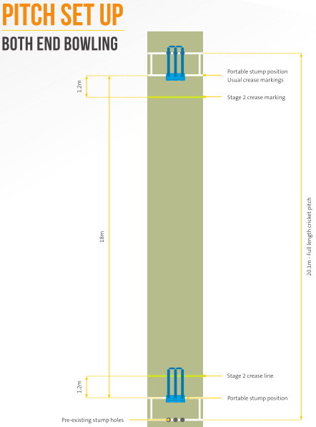

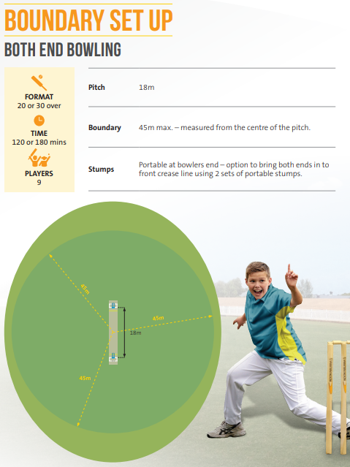

UNDER U14B CRICKET RULESHEET
Coach | - Accredited Community (Level 1) Coach
Game Type | - 28 over 1-Day games (no re-bowls)
Ball | - 142g leather cricket ball.
Time | All games to commence at 8:30am  The first innings is completed at 10:15am
Equipment | - Helmets must be worn at all times whilst batting & wicket-keeping.  - Pads, Gloves, Protector  - Additional safety equipment can be worn based on match conditions and/or personal preference.  - 2 sets of portable stumps recommended (with base and bails) – minimum 1 set of portable stumps required.  - Bat size: Outdoor bat measured to suit player size and strength  - 142g hard or leather ball.  - Measuring tape or string to measure pitch length and boundary.  - Boundary markers  - Chalk, tape or paint to mark crease.
Boundary | 45m (max) - measured from the middle of the wicket
Pitch length | 18m length measured stump to stump  * option to move stumps in at each end to the 2 crease lines (17.7m)
Stumps | Spring-back stumps are preferred by the DDJCA
Overs | 28 overs per team (1-Day game)  Teams to bowl 14 overs per end, rotating each end, until overs are complete.
Pitch length | 18m length measured stump to stump  * option to move stumps in at each end to the 2 crease lines (17.7m)
Team Size | - 11 players per team on the field  - 7 players per team is the minimum required to play the game.  - 13 players is the maximum to be registered to a team (maximum 11 players on field at any given time).  - A team must have a minimum of six (6) players of their own club, 15 minutes after the scheduled commencement time of play to constitute sufficient players to play a match otherwise a forfeit will be declared. If players are to be loaned to opposing teams they can only field in a twelfth man capacity for the opposing team.
Innings | 1 innings of 28 overs per team (1-Day game)
UNDER U14B CRICKET RULESHEET (Cont’d)
Batting | • A maximum of 11 players can bat  • All batters retire at 30 balls 1-Day game (with the assumption that some players will be dismissed)  • Any retired batters can return when all others have batted, in the order they retired  • All balls (regardless of whether wides/ no balls) will be included in the batter’s ball count.  • The innings is deemed as closed after 10 wickets have fallen
Bowling | 1-Day Game (28 Overs)  • A maximum of 11 players can bowl.  • Maximum of 6 balls per over. Wides and no balls count as one run in sundries against the bowler, but are not re-bowled. The exception is the last over of each innings which must consist of six (6) legal deliveries. There is no maximum number of balls that can be bowled for the last over.  • All players are to bowl (each Wicket-Keeper is to bowl at least one over each)  • e.g. 8 players x 3 overs, 1 player x 2 overs, 2 players x 1 over (i.e. Wicket-Keepers). If more than 11 players available, Wicket-Keepers can be non-bowlers.  • Coaches are encouraged to rotate the opportunity for players to bowl a maximum of 4 overs in a match  • Bowlers change ends at 14 overs  • Current Cricket Australia Pace Bowling guidelines apply (please refer to Well Played - Australian Cricket’s Playing Policies & Community Guidelines)

UNDER U14B CRICKET RULESHEET (Cont’d)
Bowling  Extras | NO-BALLS  1. On synthetic or concrete pitches, a ball initially landing off the pitch is a No-Ball, and is called as soon as it lands.  2. Any dangerous or fast deliveries which pass over the level of the batsman shoulder in the normal stance shall be called a no-ball by either umpire.  3. Any full pitched delivery over waist height shall be deemed a No-Ball for all bowlers.  4. A ball bouncing more than once before the popping crease shall be deemed a no ball.  WIDES  1. In judging a wide, the umpire shall call and signal a wide ball only after it has passed the line of the striker’s wicket. The umpire shall not call a wide if:  a) The striker, by moving from his guard position, causes the ball to pass out of reach.  b) The striker moves and brings the ball within his reach but then chooses to let it go.  DEAD BALL  1. If a ball is hit from the bat & hits overhead wires, it will called as a dead ball and replayed. If it strikes overhead wires from a throw, the play continues.  2. A bad bounce off the join in a synthetic pitch is called a dead ball and is replayed.
Fielding | • Rotation of fielders is recommended to ensure all players experience all positions.  • No fielders within 10 metres (except regulation off side slips, gully and wicket keeper)  • Each team is required to use two (2) wicket keepers (10 overs each in T20 games, 14 overs each in 1-Day games)  • If more than 11 players are present at a match, they should rotate onto the field each over.  • Field restrictions in place for the duration of the innings:  Two fielders must be on the boundary (within 4 metres) at the point of delivery. If 9 or less fielders (including keeper and bowler), this restriction is removed. (The intent of this rule is to allow the batter more opportunity to hit through the infield).
Dismissals | All modes of dismissal count  *U14B – Standard LBW rules apply, no warnings required.
Coaches also need to abide with the player participation requirements of junior cricket

UNDER 14A’s CRICKET RULESHEET

  - A team must have a minimum of seven (7) players of their own club, 15 minutes after the scheduled commencement time of play to constitute sufficient players to play a match otherwise a forfeit will be declared. If players are to be loaned to opposing teams they can only field in a twelfth man capacity for the opposing team.
  - ALL GAMES - start at 8:30am
    - Each team must have an umpire and scorer for the duration of the match. The use of the MyCricket app is encouraged, but each team must still maintain a paper scorebook.
    - Boundaries are set to 45 metres (each team to provide markers) or as determined by field markings.
    - The ball to be used is a 156g leather ball.
    - Wides and no balls count as one run in sundries against the bowler. There is to be a maximum of 8 balls per over, except for the last over of the innings, which must consist of six legal deliveries. There is no maximum number of balls that can be bowled for the last over.
    - No balls
      - A ball bouncing more than once before the popping crease shall be deemed a no ball.
      - A no ball to be called immediately when the ball initially lands off the synthetic or recognised pitch. This includes balls that pitch on the edge where the synthetic joins the concrete, and off the rolled area on turf pitches.
      - ANY ball that passes, or would have passed, above the waist of a batsman standing upright on the crease, on the full is to be called a no ball. This applied to all bowlers, including spinners. Bowlers ARE NOT to be removed from bowling, regardless of the number of such deliveries, unless the umpire deems any to have been deliberate.
    - Wides.
      - A delivery is a wide if the ball passes wide of where the striker is standing and which would have also passed wide of the striker in a normal guard position. It is wide if it cannot be hit with the bat using a normal cricket stroke.
      - A ball is not a wide if the striker, by moving from their guard position, causes the ball to pass out of reach
      - A ball is not a wide if the striker moves and brings the ball within their reach but then chooses to let it go
    - A ball that pitches in the middle of the pitch where the 2 pieces of synthetic join shall be deemed a dead ball. It shall be re-bowled.
    - The LBW law does apply.
    - Restrictions on players
      - Batsmen resuming innings. Any batsman having been compulsorily retired, may resume his innings only after all other batsman have been dismissed or compulsorily retired. For example, if a batsman has been compulsorily retired, they cannot resume their innings if any other batsman has been voluntarily retired (except in the case of retired hurt). A voluntarily retired batsmen cannot resume their innings under any circumstances, aside from having retired hurt. A retired batsman (compulsory, voluntary or retired hurt) is to be recorded “retired not out” in “MyCricket” so does not count as a wicket for averages.
      - Wicket keepers. Wicket keepers must wear a suitable cricket helmet whilst in that position.
      - Fielders. Apart from the wicketkeeper and slips, no fielder is to field within 10 metres of the batsman on strike.
    - Change of innings. No loss of overs for change of innings.
    - Coaches also need to abide with the player participation requirements of junior cricket

  - ONE DAY GAMES
    - Matches to be played as 25 overs per side
    - Restrictions on players
      - Batsmen retiring. A batsman must retire immediately after the scoring shot that takes them to or past 50 runs. E.g. if the batsman is on 49 then scores 4 runs then they retire on 53.
      - Bowlers. No player may bowl more than 4 overs in the innings
      - Team. A team may have up to 13 players available for a day’s play. However, only 11 players may bat during a day’s play, and 11 may bowl during a day’s play. Some players who bat may not bowl, and vice versa, allowing all players to participate. If at least 11 registered players for a team are available, no other players may bat or bowl.
    - Loss of overs and result
      - Teams may not declare their innings closed in a one day game.
      - Minimum overs. Should time be lost due to rain, equal overs for both teams will apply to achieve a result, subject to minimum 15 overs being bowled by each team (unless one is dismissed).
      - Equal overs. If equal overs are unable to be achieved by each team then a draw is declared even through the minimum overs have been bowled (unless one team has been dismissed).
14.4. TWO DAY GAMES – Quarters cricket
14.4.1. Matches to be played as 46 overs per side
14.4.1.1. Day 1: Team A bats first for 23 overs (Team A overs 1-23) and then its 1st innings is suspended. Team B bats second up to end of day 1 to complete 23 overs of its first innings (Team B overs 1-23).
14.4.1.2. Team B bats to complete its first innings overs (Team B overs 24-46). Team A than resumes its first innings to complete its overs (Team A overs 24-46).
14.4.2. Restrictions on players
14.4.2.1. Batsmen retiring. A batsman must retire immediately after the scoring shot that takes them to or past 50 runs. E.g. if the batsman is on 49 then scores 4 runs then they retire on 53.
14.4.2.2. Bowlers - overs. No player may bowl more than 9 overs in the innings.
14.4.2.3. Bowlers - non-spinners’ spells Bowlers (excluding spinners) may bowl no more than 5 overs in a spell in an innings. The minimum rest periods between spells will be at least the same number of overs bowled from the same end as the bowlers’ immediately concluded spell, i.e. if a bowler has a spell of 4 overs he cannot bowl again until 4 overs have been bowled from his end. (eight overs total). This does not include if a bowler is simply changing ends in the spell. A spell can be over two days but cannot exceed the maximum overs in the spell, e.g. 3 overs the first week, the bowler then can only bowl 2 overs the next week in that spell. The minimum rest periods also apply over the two days. There are no restrictions on how many spells a bowler may have.
14.4.2.4. Bowlers – Spinners’ spells Spin bowlers may bowl without rest periods. A spin bowler is classified as a slow bowler, where the wicket keeper normally stands up to the stumps. If the spin bowler changes their speed to faster than what would be classified as a slow bowler, the bowler will be restricted by the rest periods in
14.4.2.3. The umpires must determine if a bowler has changed their action.
14.4.2.5. Team. A team may have up to 13 players available for a day’s play. However, only 11 players may bat during a day’s play, and 11 may bowl during a day’s play. Some players who bat may not bowl, and vice versa, allowing all players to participate. The 11 bowlers and batsmen may differ from Day 1 to Day 2. However, if at least 11 players of the registered team squad are available on a day, no other players may bat or bowl on that day. This clause also does not apply for finals.
14.4.3. Loss of overs and result
14.4.3.1. Minimum overs. Should time be lost due to rain, both teams must have the opportunity to face the same number of overs (unless one is dismissed) to constitute a result. This is subject to a minimum of 24 overs being bowled by each team (unless one team is dismissed or declares). DUBBO DISTRICT JUNIOR CRICKET ASSOCIATION - GAME-DAY RULESHEETS 26
14.4.3.2. Overs lost to delays – Day 1. If a game fails to complete 46 overs on the first day because of wet weather or similar delay, then the remaining overs in the match are to be shared equally (e.g. 29 overs bowled on first day – add 46 overs from Day 2= 75 overs. Therefore each team will bowl 75/2 = 38 overs (rounded up).
14.4.3.3. Overs lost to delays – Day 2. If the second day is interrupted by wet weather or similar delays, and equal overs are unable to be achieved by each team then a draw is declared. This will occur even though the minimum overs have been bowled, unless a result has already been achieved.
14.4.3.4. Result on first day. No result in the first day is possible unless a team has been dismissed or declared and the opposition has passed the score.
14.4.3.5. If the team batting second is dismissed before 11:10am on the first day, the team batting first will recommence its first innings and may bat the remainder of the unused overs of Day 1. It may continue to bat on Day 2 for as long as required to achieve a first innings win, or it is dismissed. Any uncompleted over will counted as a completed over when the first innings is finished. Eg; if Team B is bowled out after 19.3 overs, the game will reflect 20 completed overs.
14.4.3.6. First day completely washed out. If the whole of the first day’s play is washed out, then a one day game will be played the next weekend (see 14.3).
14.4.4. Second innings’, outrights and follow-ons
14.4.4.1. The match may be concluded after the 1st innings of both teams has been completed, unless both coaches agree to pursue an outright result. The total number of overs do not change
14.4.4.2. Unused overs. If a team is dismissed or declares its first innings within its allocated 46 overs (or revised number due to delays), the other team can access the unused (whole) overs in their innings as well as their original allotted overs. However, no team shall bat for more than half the available overs on Day 2.
14.4.4.3. An outright result is available if game circumstances allow.
14.4.4.4. To enforce a follow-on, a team must lead by at least 75 runs.
14.4.4.5. Player participation. Whilst second innings’ are an opportunity for extra points, coaches are urged to use them as an opportunity to even out player participation.
14.4.5. Match moved between Week 1 and Week 2 For games played on turf pitches, if it is wet on the first day, the games are moved to synthetic where possible. If the turf pitch is playable on the second day’s play, the game moves and continues on turf pitches. If the first day was played a turf pitch, then is not possible on the second day, the game moves and will continue on synthetic where possible. DUBBO DISTRICT JUNIOR CRICKET ASSOCIATION - GAME-DAY RULESHEET

UNDER 16’s CRICKET RULESHEET

  - A team must have a minimum of seven (7) players of their own club, 15 minutes after the scheduled commencement time of play to constitute sufficient players to play a match otherwise a forfeit will be declared. If players are to be loaned to opposing teams they can only field in a twelfth man capacity for the opposing team
  - ALL GAMES - start at 8:30am
    - Each team must have an umpire and scorer for the duration of the match. The use of the MyCricket app is encouraged, but each team must still maintain a paper scorebook.
    - Boundaries are as determined by field markings.
    - The ball to be used is a Red 156g leather ball.
    - Wides and no balls count as one run in sundries against the bowler. There is to be a maximum of 8 balls per over, except for the last over of the innings, which must consist of six legal deliveries. There is no maximum number of balls that can be bowled for the last over.
    - No balls
      - A ball bouncing more than once before the popping crease shall be deemed a no ball.
      - A no ball to be called immediately when the ball initially lands off the synthetic or recognised pitch. This includes balls that pitch on the edge where the synthetic joins the concrete, and off the rolled area on turf pitches.
      - ANY ball that passes, or would have passed, above the waist of a batsman standing upright on the crease, on the full is to be called a no ball. This applied to all bowlers, including spinners. Bowlers ARE NOT to be removed from bowling, regardless of the number of such deliveries, unless the umpire deems any to have been deliberate.
    - Wides.
      - A delivery is a wide if the ball passes wide of where the striker is standing and which would have also passed wide of the striker in a normal guard position. It is wide if it cannot be hit with the bat using a normal cricket stroke.
      - A ball is not a wide if the striker, by moving from their guard position, causes the ball to pass out of reach
      - A ball is not a wide if the striker moves and brings the ball within their reach but then chooses to let it go
    - A ball that pitches in the middle of the pitch where the 2 pieces of synthetic join shall be deemed a dead ball. It shall be re-bowled.
    - The LBW law does apply.
    - Restrictions on players
      - Batsmen resuming innings. Any batsman having been compulsorily retired, may resume his innings only after all other batsman have been dismissed or compulsorily retired. For example, if a batsman has been compulsorily retired, they cannot resume their innings if any other batsman has been voluntarily retired (except in the case of retired hurt). A voluntarily retired batsmen cannot resume their innings under any circumstances, aside from having retired hurt. A retired batsman (compulsory, voluntary or retired hurt) is to be recorded “retired not out” in “MyCricket” so does not count as a wicket for averages.
      - Wicket keepers. Wicket keepers must wear a suitable cricket helmet whilst in that position.
      - Fielders. Apart from the wicketkeeper and slips, only one fielder is to field within 10 metres of the batsman on strike, and they must be wearing an approved helmet, with a face guard.
    - Change of innings. No loss of overs for change of innings.
    - Coaches also need to abide with the player participation requirements of junior cricket

  - ONE DAY GAMES
    - Matches to be played as 25 overs per side
    - Restrictions on players
      - Batsmen retiring. A batsman must retire immediately after the scoring shot that takes them to or past 50 runs. E.g. if the batsman is on 49 then scores 4 runs then they retire on 53.
      - Bowlers. No player may bowl more than 4 overs in the innings
      - Team. A team may have up to 13 players available for a day’s play. However, only 11 players may bat during a day’s play, and 11 may bowl during a day’s play. Some players who bat may not bowl, and vice versa, allowing all players to participate. If at least 11 registered players for a team are available, no other players may bat or bowl.
    - Loss of overs and result
      - Teams may not declare their innings closed in a one day game.
      - Minimum overs. Should time be lost due to rain, equal overs for both teams will apply to achieve a result, subject to minimum 15 overs being bowled by each team (unless one is dismissed).
      - Equal overs. If equal overs are unable to be achieved by each team then a draw is declared even through the minimum overs have been bowled (unless one team has been dismissed).
16.4. TWO DAY GAMES – Quarters cricket
16.4.1. Matches to be played as 46 overs per side
16.4.1.1. Day 1: Team A bats first for 23 overs (Team A overs 1-23) and then its 1st innings is suspended. Team B bats second up to end of day 1 to complete 23 overs of its first innings (Team B overs 1-23).
16.4.1.2. Team B bats to complete its first innings overs (Team B overs 24-46). Team A than resumes its first innings to complete its overs (Team A overs 24-46).
16.4.2. Restrictions on players
16.4.2.1. Batsmen retiring. A batsman must retire immediately after the scoring shot that takes them to or past 100 runs. E.g. if the batsman is on 99 then scores 4 runs then they retire on 103.
16.4.2.2. Bowlers - overs. No player may bowl more than 9 overs in the innings.
16.4.2.3. Bowlers - non-spinners’ spells Bowlers (excluding spinners) may bowl no more than 5 overs in a spell in an innings. The minimum rest periods between spells will be at least the same number of overs bowled from the same end as the bowlers’ immediately concluded spell, i.e. if a bowler has a spell of 4 overs he cannot bowl again until 4 overs have been bowled from his end. (eight overs total). This does not include if a bowler is simply changing ends in the spell. A spell can be over two days but cannot exceed the maximum overs in the spell, e.g. 3 overs the first week, the bowler then can only bowl 2 overs the next week in that spell. The minimum rest periods also apply over the two days. There are no restrictions on how many spells a bowler may have.
16.4.2.4. Bowlers – Spinners’ spells Spin bowlers may bowl without rest periods. A spin bowler is classified as a slow bowler, where the wicket keeper normally stands up to the stumps. If the spin bowler changes their speed to faster than what would be classified as a slow bowler, the bowler will be restricted by the rest periods in
16.4.2.3. The umpires must determine if a bowler has changed their action.
16.4.5.1. Team. A team may have up to 13 players available for a day’s play. However, only 11 players may bat during a day’s play, and 11 may bowl during a day’s play. Some players who bat may not bowl, and vice versa, allowing all players to participate. The 11 bowlers and batsmen may differ from Day 1 to Day 2. However, if at least 11 players of the registered team squad are available on a day, no other players may bat or bowl on that day. This clause also does not apply for finals.
16.4.3. Loss of overs and result
16.4.3.1. Minimum overs. Should time be lost due to rain, both teams must have the opportunity to face the same number of overs (unless one is dismissed) to constitute a result. This is subject to a minimum of 24 overs being bowled by each team (unless one team is dismissed or declares).
16.4.3.2. Overs lost to delays – Day 1. If a game fails to complete 46 overs on the first day because of wet weather or similar delay, then the remaining overs in the match are to DUBBO DISTRICT JUNIOR CRICKET ASSOCIATION - GAME-DAY RULESHEETS 30 be shared equally (e.g. 29 overs bowled on first day – add 46 overs from Day 2= 75 overs. Therefore each team will bowl 75/2 = 38 overs (rounded up).
16.4.3.3. Overs lost to delays – Day 2. If the second day is interrupted by wet weather or similar delays, and equal overs are unable to be achieved by each team then a draw is declared. This will occur even though the minimum overs have been bowled, unless a result has already been achieved.
16.4.3.4. Result on first day. No result in the first week is possible unless a team has been dismissed or declared and the opposition has passed the score.
16.4.3.5. If the team batting second is dismissed before 11:10am on the first day, the team batting first will recommence its first innings and may bat the remainder of the unused overs of Day 1. It may continue to bat on Day 2 for as long as required to achieve a first innings win, or it is dismissed. Any uncompleted over will counted as a completed over when the first innings is finished. Eg; if Team B is bowled out after 19.3 overs, the game will reflect 20 completed overs.
16.4.3.6. First day completely washed out. If the whole of the first day’s play is washed out, then a one day game will be played the next weekend.
16.4.4. Second innings’, outrights and follow-ons
16.4.4.1. The match may be concluded after the 1st innings of both teams has been completed, unless both coaches agree to pursue an outright result. The total number of overs do not change.
16.4.4.2. Unused overs. If a team is dismissed or declares its first innings within its allocated 46 overs (or revised number due to delays), the other team can access the unused (whole) overs in their innings as well as their original allotted overs. However, no team shall bat for more than half the available overs on Day 2.
16.4.4.3. An outright result is available if game circumstances allow.
16.4.4.4. To enforce a follow-on, a team must lead by at least 75 runs.
16.4.4.5. Player participation. Whilst second innings’ are an opportunity for extra points, coaches are urged to use them as an opportunity to even out player participation.
16.4.5. Match moved between Week 1 and Week 2 For games played on turf pitches, if it is wet on the first day, the games are moved to synthetic where possible. If the turf pitch is playable on the second day’s play, the game moves and continues on turf pitches. If the first day was played a turf pitch, then is not possible on the second day, the game moves and will continue on synthetic where possible.

MAP OF GROUNDS
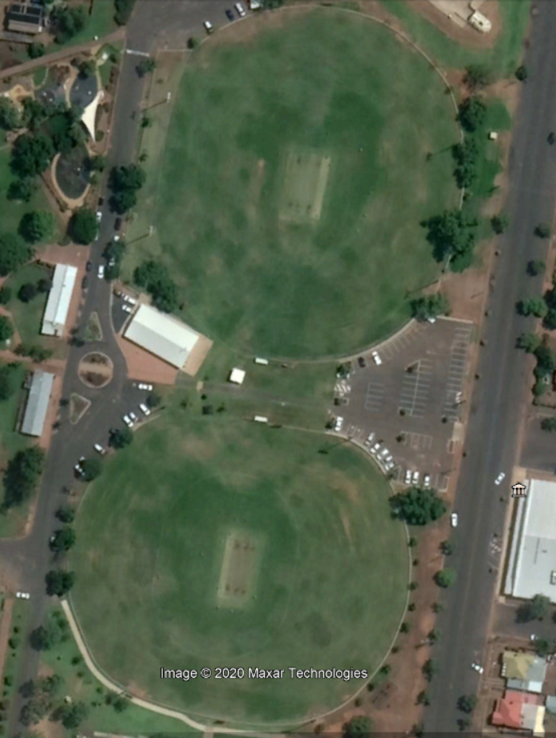
Victoria Lane
Gipps St
Victoria Park 2
Victoria Park 3
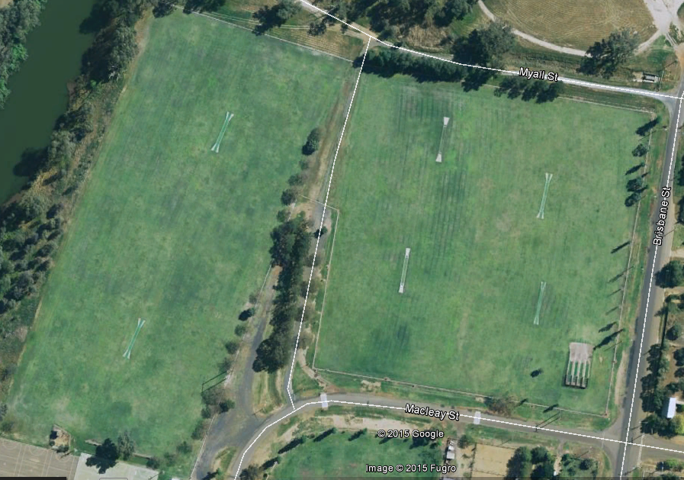
John McGrath 1
John McGrath 2
Bob Dowling 4
Bob Dowling 1
Bob Dowling 2
Bob Dowling 3
Macleay St
Brisbane St

Dave Martin Nets

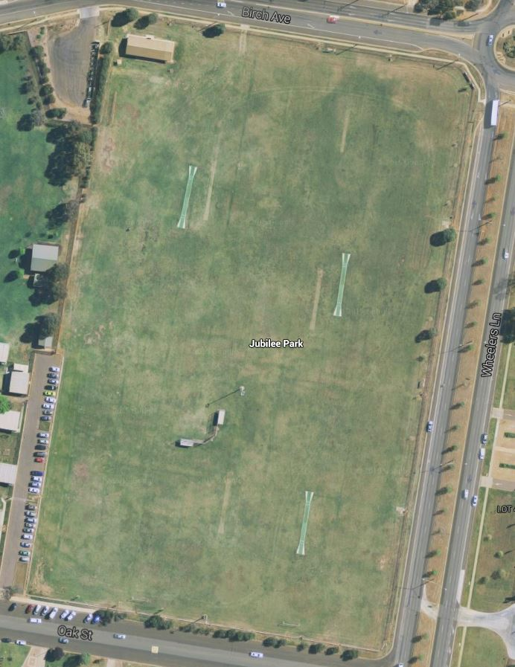
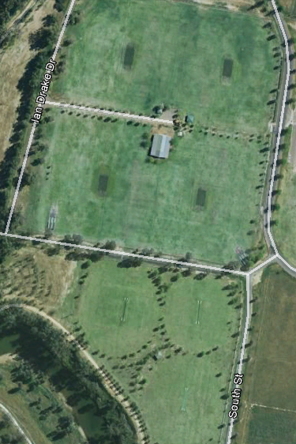
Jubilee 1
Jubilee 2
Jubilee 3
Wheelers Lane
Lady Cutler 1
Lady Cutler 2
Lady Cutler South C
Lady Cutler South B
Lady Cutler South A
Bligh St
Lady Cutler 4
Lady Cutler 3
Lady Cutler Nets East
Lady Cutler Nets West
Lady Cutler 4

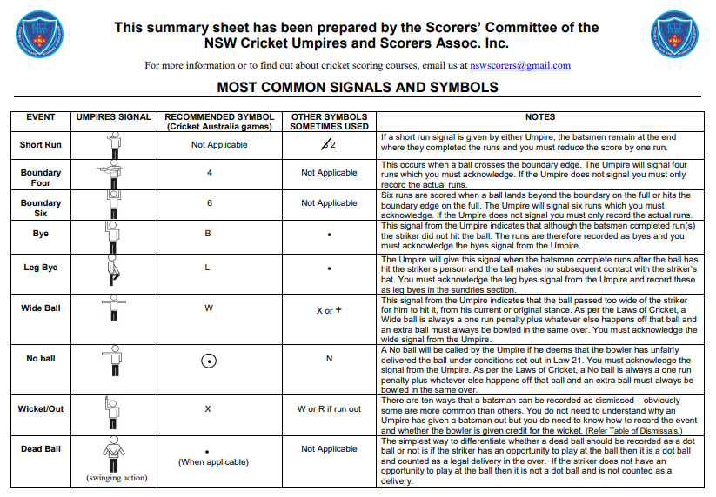
Location of Defibrillators at Local Cricket Grounds
GROUND | SPECIFIC LOCATION | KEY NEEDED
Vic Park 1 | Scorers box in the grandstand | Any Vic Park key
Vic Park 2 & 3 | Disabled toilet in amenities block | Any Vic Park key
Lady Cutler | Eastern side change room | Lady Cutler key
Jubilee Oval | Women’s toilet (north end of ground) | No. 2 key
John McGrath/Bob Dowling | Women’s toilet in public toilet block | No. 2 key
Pioneer (Dubbo) | Women’s change room | Pioneer (Dubbo) key
South Dubbo Oval | Women’s change room | No. 2 key
Pioneer (Wellington) | Women’s change room | Pioneer (Wello) key
Rygate Park | Disabled toilet | Rygate key

END

